On possible infringement issues arising from the use of Artificial intelligence in the field of painting and visualization

Abstract
With the rapid development of ai models today, it has become feasible to use Artificial intelligence model training to produce images. But also due to the rapid development of technology and some copyright issues have caused some controversy in between. This paper is intended to discuss whether the training process of Artificial intelligence models may cause infringement to the images used as training material and the artists who created them.

Key words
Artificial intelligence, learning, copyright, plagiarism, painting

Main article

Background
Within 50 years, Artificial intelligence training has become possible due to the rapid rise in computer and programming levels. Alibaba launched a "scriptwriting robot" in 2015, and the OpenAI organization founded by Musk developed an AI system that beat humans in a Dota 2 match. The same AI model training has a wide range of uses in the arts, such as automatic background generation and AI painting. And this is all thanks to the creation of a new algorithm that was first proposed by lan Goodfellow in 2014 in 《GenerativeAdversarialNets》, that is GAN. It can generate real data in the field of machine learning through complex data in the latent space. Thus, it has gained a great improvement in model training.
And I will briefly explain how it works in AI painting with a picture.
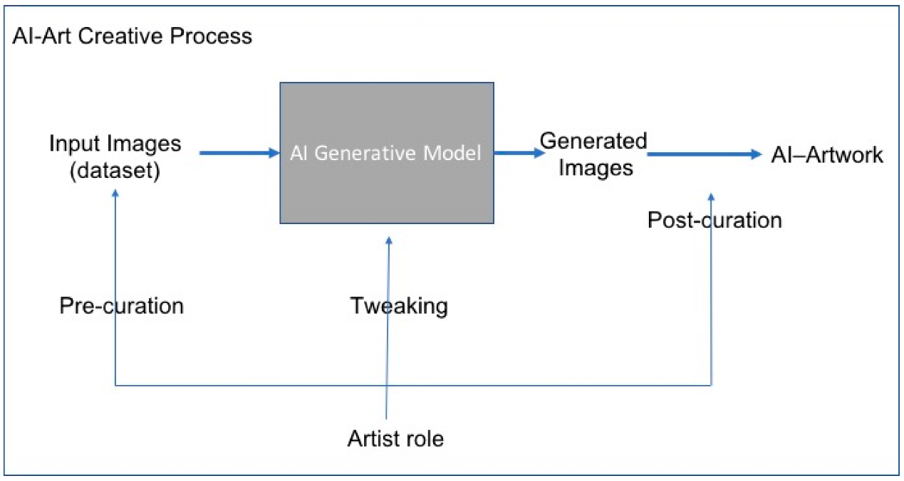
A block diagram showing the artist’s role using the Artificial intelligence generative model in making art. Diagram cre
So, this is a very good understanding of the illustration, we do not need to understand the specific structure of the internal composition of the model, but only the rules of operation of the model, and this will help us to better understand the following content.

Some people‘s point
Some artic feel angry when their picture use to training.
This training and the use of Artificial intelligence did affect some of the painters. A significant number of them think that Artificial intelligence painting is a mere collage of their work. Weibo user "Dora Xiaoxi" once expressed his opinion on his work appearing in the AI training library, "Not ...... don't catch me works to copy ，do admit it, I'm not blind. Artificial intelligence really isn't for you to use like this. ". And Weibo user "Xiao Crow_RSA" also expressed a similar view, he clearly expressed his opinion that using his own paintings to train Artificial intelligence is a blatant infringement. This shows that some of the artists' authors think it is illegal to use their own works as AI training. At the same time, many of the artist's fans also hold this view.

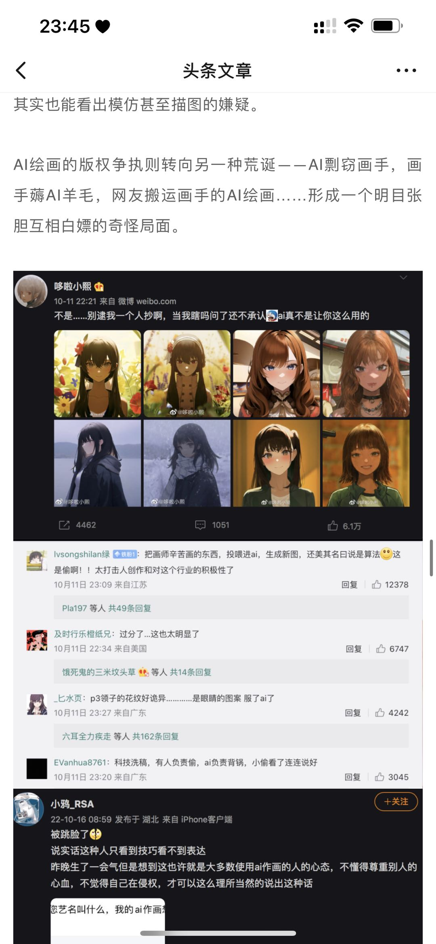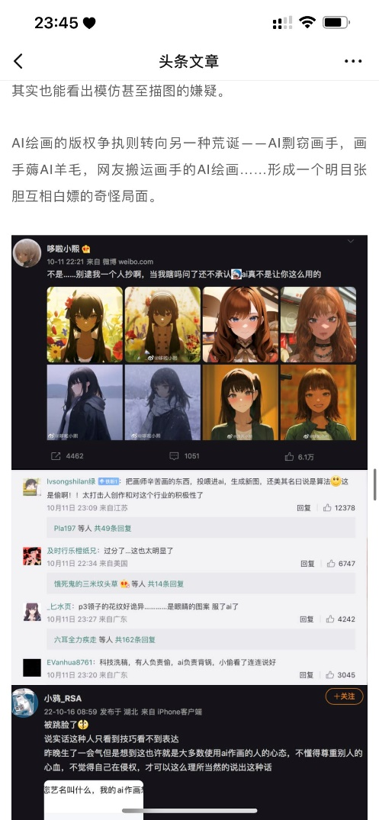
user "Dora Xiaoxi"(1st from left)
user "Xiao Crow_RSA"(right 1)
It is understandable that they are angry, but in their opinion, the use of their work for training purposes also requires their authorization. This right of use, just like the right of ownership, requires the permission of the artist himself. The use of second-hand images obtained through crawlers or pirated websites for training AI models is certainly an infringement. Also, because most of the artists have a negative attitude towards the existence of Artificial intelligence models, it is extremely difficult for the artists to open the license to Artificial intelligence models.
The special point of this case is that in the AI training, to what extent should these authors' works be used, or to what extent should the final product be similar to the training material before it can be judged as plagiarism? Or is the use of all unlicensed images used in AI training already considered an infringement? Perhaps these artists hold both arguments against the use of their images in the AI training process and are convinced that it is an act of infringement and plagiarism.

My point
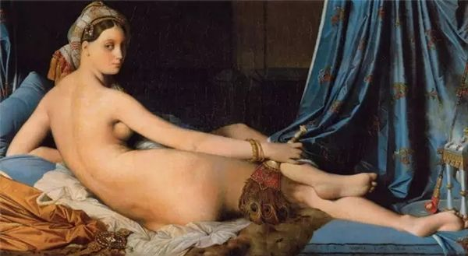
Engel's 《The Great Courtesan》
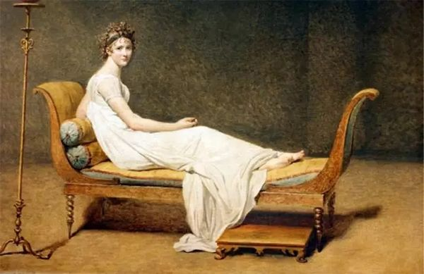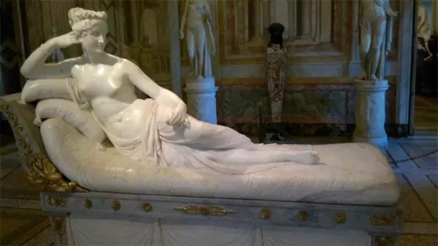
《Portrait of Madame Recamier》 painted by Jacques-Louis Davide for a woman (1st from left)
Italian neoclassical sculptor Antonio Canova's marble statue 《Paulina Borghese dressed as Venus of Victor》 (right 1)
But we're doing the same thing as Artificial intelligence.
So, I don't subscribe to this view for one very simple reason - imitation is the way to learn. All those who learn art begin with imitation, starting with the cave paintings of 30,000 BC, when people began to draw bison and horses by imitating nature through painting. As their skills became more sophisticated, people began to sculpt, paint, and record themselves in imitation of humans. The Renaissance, in recreating and imitating the ancient Greek style, also produced numerous wonderful works. All the way to the present-day art students who learn how to describe structure and light and shadow from the works of famous painters like Leonardo da Vinci Rembrandt, color from the Rococo, and elaborate shapes from Baroque art. Even if the French artists of the nineteenth century spent as much energy to prove that their works were their independent creations, they could not erase their learning of the human body, their learning of color, their learning of composition. And these studies were made by going to imitate or watching the works of their predecessors. But no one would consider their creations to be plagiarism or infringement. Because if we can't inherit the knowledge of the past, we can't make more progress. Even now, people still admire other people's work on the Internet and learn from what they do well, which is why people are making progress.
And in the late history of Western art, the emergence of modern art, pop art even itself is made of many popular elements spliced together, so is pop art also an illegal genre now?
And can the use of the same elements in paintings also be attributed to infringement and plagiarism? Is it not the case that Engel's "The Great Courtesan" refers to Jacques-Louis Davide's "Portrait of Madame Recamier" painted for a woman and the Italian neoclassical sculptor Antonio Canova's marble statue "Paulina Borghese in the guise of Venus of Victory"? And there are countless paintings of the same elements in art history, such as the Madonna painted by various painters during the Renaissance, which even maintained the same pose. This shows that holding the same elements or the same pose for a painting of the same subject is not a criterion for judging whether it is infringement or plagiarism.

The learning process of Artificial intelligence models is just like human learning, it is not simply piecing together details from other people's paintings as many people think, such as taking a beautiful eye from this painting and then taking a detailed hair from another picture. They are engaged in a learning process where they learn the meaning and expression of different words from thousands of images. There are probably hundreds of ways to draw hair, from which they learn and generalize the meaning of the word "hair". They learn how to draw, how to deal with light and shadow, just like humans do. They don't directly imitate a specific painting and try to call that work directly when they use certain words. They are actually "creating" (I use double quotes here because creating is a process that requires human participation, which Artificial intelligence clearly is not), not just copying. So, it's hard to say that the work it produces through learning will infringe on the artists it's training, because then all of us designers are infringing when we do projects, because we can't create things out of thin air, we need to find some reference work. And obviously that's not valid. I mean - who's going to say that all the work that hits a single sidelight or a cellar light is an infringement of Rembrandt? It's an exaggerated joke, of course, but that's exactly the point I'm trying to make. It is not an infringement to create an expression by learning the characteristics of someone else's work. Do all portrait painters to this day have to apologize to the Greek painter Apelles or Leonardo da Vinci?
The only way to prevent others from learning from one's work is to not create and display one's own work, otherwise all those who view it will learn something from it. It is often difficult to prohibit others from studying one's own work by mere declaration, because the subjective motivation of others to copy, learn, borrow, and innovate cannot be stopped.
So, is this the best solution (meaning no more public display of one's work)? If not, then stop thinking that the process of Artificial intelligence training is infringing and plagiarizing. Perhaps one can have some disputes about the ownership of its final output, but there is no such problem in the training process.

In terms of Chinese law, the learning process does not carry out infringement. And there is no profit-making part in the whole training process of the Artificial intelligence model. If the training process does not have any profit purpose, the premise of infringement does not exist.
Nowadays, artists seem to take the matter of plagiarism very seriously. Having the same drawing habits is an infringement and plagiarism; drawing the same angle of a character's face is an infringement and plagiarism; even the similarity in color scheme can be branded as plagiarism and infringement and hung on the Internet for public criticism. Perhaps today, as AI models are gradually developing, the copyright problem faced in Artificial intelligence model training can make us reflect on our current public perception of plagiarism and infringement as well. This may also be an opportunity for us to recognize the boundary between copying and plagiarism, instead of becoming the "one word" of some painters.

Bibliography

Some excerpts from the Copyright Law of the People's Republic of China

第四节 权利的限制
第二十四条 在下列情况下使用作品，可以不经著作权人许可，不向其支付报酬，但应当指明作者姓名或者名称、作品名称，并且不得影响该作品的正常使用，也不得不合理地损害著作权人的合法权益：
（一）为个人学习、研究或者欣赏，使用他人已经发表的作品；
（二）为介绍、评论某一作品或者说明某一问题，在作品中适当引用他人已经发表的作品；
（三）为报道新闻，在报纸、期刊、广播电台、电视台等媒体中不可避免地再现或者引用已经发表的作品；
（四）报纸、期刊、广播电台、电视台等媒体刊登或者播放其他报纸、期刊、广播电台、电视台等媒体已经发表的关于政治、经济、宗教问题的时事性文章，但著作权人声明不许刊登、播放的除外；
（五）报纸、期刊、广播电台、电视台等媒体刊登或者播放在公众集会上发表的讲话，但作者声明不许刊登、播放的除外；
（六）为学校课堂教学或者科学研究，翻译、改编、汇编、播放或者少量复制已经发表的作品，供教学或者科研人员使用，但不得出版发行；
（七）国家机关为执行公务在合理范围内使用已经发表的作品；
（八）图书馆、档案馆、纪念馆、博物馆、美术馆、文化馆等为陈列或者保存版本的需要，复制本馆收藏的作品；
（九）免费表演已经发表的作品，该表演未向公众收取费用，也未向表演者支付报酬，且不以营利为目的；
（十）对设置或者陈列在公共场所的艺术作品进行临摹、绘画、摄影、录像；
（十一）将中国公民、法人或者非法人组织已经发表的以国家通用语言文字创作的作品翻译成少数民族语言文字作品在国内出版发行；
（十二）以阅读障碍者能够感知的无障碍方式向其提供已经发表的作品；
（十三）法律、行政法规规定的其他情形。
前款规定适用于对与著作权有关的权利的限制。
第二十五条 为实施义务教育和国家教育规划而编写出版教科书，可以不经著作权人许可，在教科书中汇编已经发表的作品片段或者短小的文字作品、音乐作品或者单幅的美术作品、摄影作品、图形作品，但应当按照规定向著作权人支付报酬，指明作者姓名或者名称、作品名称，并且不得侵犯著作权人依照本法享有的其他权利。
前款规定适用于对与著作权有关的权利的限制。

（Should I translate it?）

